4

1. create accounts “moderator”, “administrator”

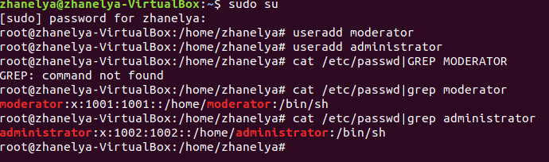

1. create group “management”

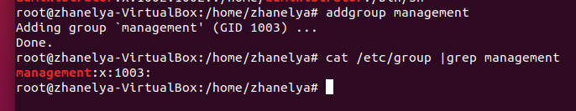

1. assign “moderator” and “administrator” to “management” group

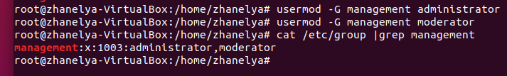

1. also assign “administrator” to “root” and “sudo” group

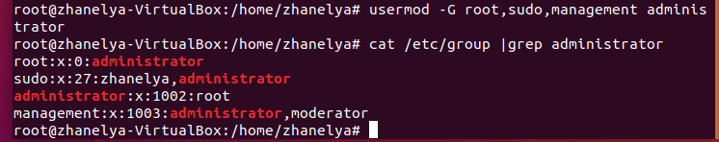

5.Create account “someuser”

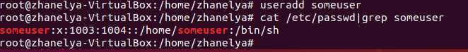

1. Create group “others”

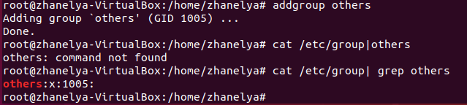

1. assign “someuser” to “others” group

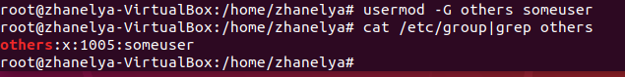

1. create a folder called “articles”

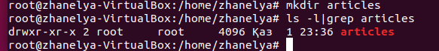

1. make the “administrator” the owner of folder “articles”

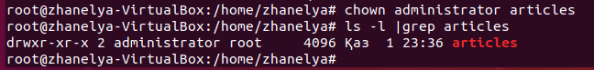

9. make the “management” group the owner group of folder “articles”

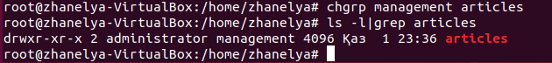

10.set full permission for owners of “article” folder and read, execute permission to others

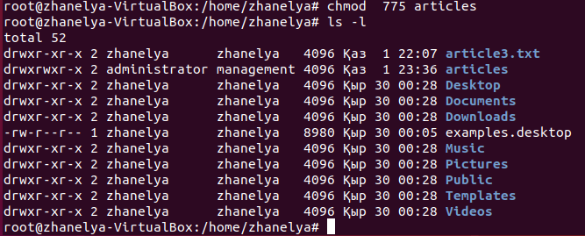

11.as “moderator” add some files called “article1.txt”, “article2.txt” … “article[n].txt” to folder “articles”

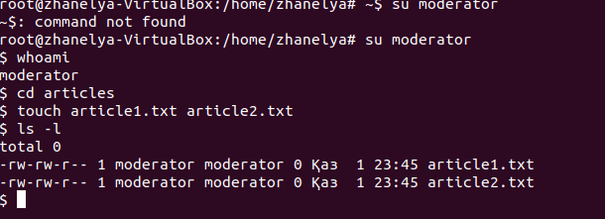

12.set full permission for owners of “article” folder and read and execute permission to others for all files in “articles” folder

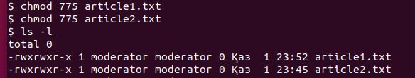

13. set the same permissions to files that will be created in the future

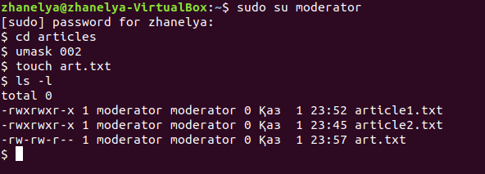

14. as “someuser”, try do delete some file in “articles” folder? is it possible?

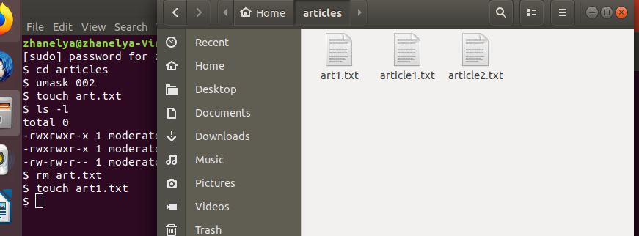

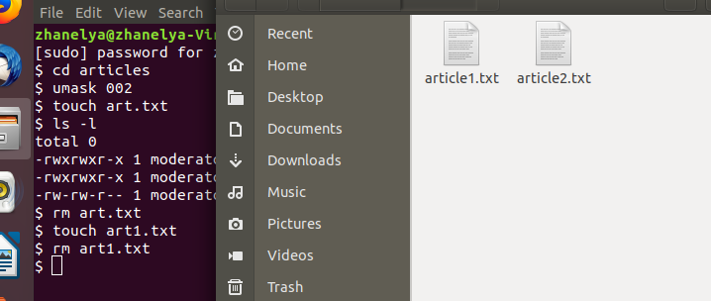

15. as administrator create folder called “backups”

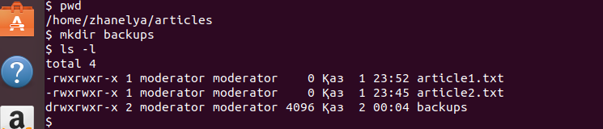

16. make the “administrator” the owner of this group, and “root” group as an owner group of folder “backups”

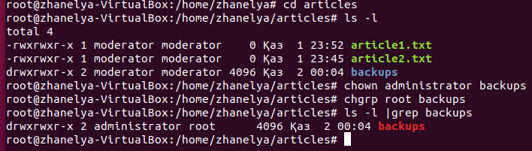

17. give full permission for folder “backups” and its content to “administrator” and group “root” and no permission to others

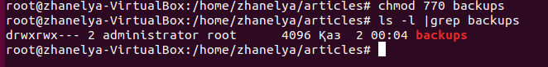

18. as “moderator” try to enter to this directory? was it possible?

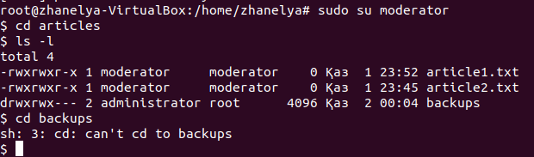

19. as “administrator” create a backup of all files in “articles” folder into “backups” folder

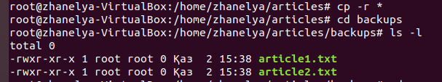

20. compress “backups” folder and give full permission to “administrator” and no permission to others for compressed file

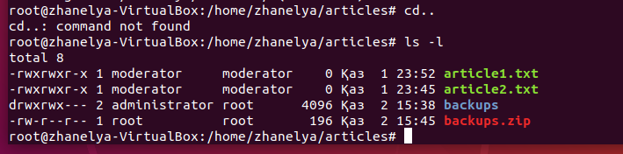

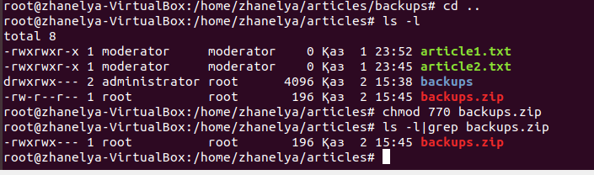

21. as “root” try to decompress backup? was it possible? what about decompressing as “moderator”?

